Southwest University
School of Computer and Information Science

Program: Computer Science and Technology
Couse Title: Principle of Programming
Chapter Title: Files and exceptions
Unit No: 06
Assignment No.: 02

Issue Date: 2021-11-25

Submission Deadline: 2021-12-2

Assessor/Tutor: Ya LI

Student Name: Cai Qianzhe

Student No.: 222021321102065

Grade：2021

NOTES TO STUDENTS
- Check carefully the submission date and the instructions given with the assignment. Late assignments will not be accepted.
- If you are unable to hand in your assignment on time and have valid reasons such as illness, you may apply (in writing) for an extension.
- If you are caught plagiarizing, you could have your grade reduced to zero, or at worst, you could be excluded from the course.
- Your submission document should include screen shots of the Python IDLE showing your code and the output results of running your code.
- Complete your assignment in Word document and submit it to FTP server
- Your file name should start with your Reg. No, and then include your name, and assignment NO. for example “222012321062259_李丹_assignment1.docx”. Remember to link different fields together using the underscore character (_).

Formatting Concerns
#1: You should have a header that explains the program
#2: There should be a space between the prompt and the place where you type in the value.
#3: Your work should be formatted nicely as in the sample output.

STUDENT’S DECLARATION:

I confirm that this is all my own work.

Student Signature: 蔡前哲

Assignment Description
Scenario and Tasks：

1. practice on exceptions
Write a program that prompts for three numbers. Divide the first number by the second number and add that result to the third number. Using exceptions check for the following errors: ValueError, and ZeroDivisionError.

Solution:

Code:

def main():
print("请输入第1个数",end=" ")
num1 = input()
print("请输入第2个数",end=" ")
num2 = input()
print("请输入第3个数",end=" ")
num3 = input()

#判断输入是否全为数字,是数字继续执行.否则数值错误,退出
if str.isdigit(num1) and str.isdigit(num2) and str.isdigit(num3) :
#全部转成数字便于计算
num1 = int(num1)
num2 = int(num2)
num3 = int(num3)

if num2 == 0 : #除数是0
print("ZeroDivisionError")
elif (num2 > num1) : #除数大于被除数 数值错误
print("ValueError")
else :
print(int(num1/num2)+num3) #没问题就输出值
else :
print("ValueError")

main()

Screen Capture of The Result:

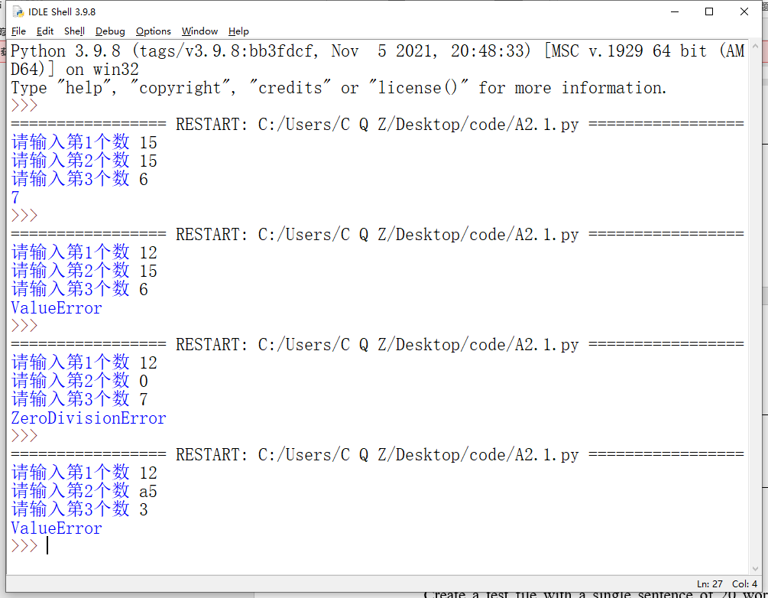

2. File reading & Writing

Create a test file with a single sentence of 20 words(one line). Read the file, then insert carriage-return characters (\n) and write the test to a new text file that will be composed of four lines of five words.

Solution:

Code:

fo = open("test.txt","r")
fn = open("testNEW.txt","w")

strold = fo.read()

#先将读入的字符串转为list
stro = []
for i in range(len(strold)) :
stro.append(strold[i])

#在列表中查找空格，每五个一组为一行，加入换行符
num = 0
for i in range(len(stro)) :
if stro[i] == " ":
num += 1
if num>0 and num%5 == 0 :
stro[i] = "\n"

#list转为字符串存入新文件
stro = "".join(stro)
fn.write(stro)

fo.close()
fn.close()

Screen Capture of The Result:

